Comprehensive School Improvement Plan

E. J. Swint Elementary School

2018-2019

Vision Statement
The vision of Clayton County Public Schools is to be a district of high performance ALL students
to live and compete successfully in a global society.

Mission Statement
The mission of Clayton County Public Schools is to empower students to achieve academic and personal goals.

Principal: Sarah Cainion

Assistant Principal(s): Ava Davis

School Leadership/Improvement Team

Name | Position
Sarah Cainion | Principal
Ava Davis | Assistant Principal
Karla Reese | Academic Coach
Claude Gatlin | Parent Liaison
Carmen Black | EIP Teacher
Tamika Crawford | ESOL Teacher
Rosalind Rogers | PTA President
Sherita Jones | Paraprofessional
Roger Swint | Community Member
Takenya Sweeper | Parent/PTA Officer
Tammy Holder | Parent/PTA Officer

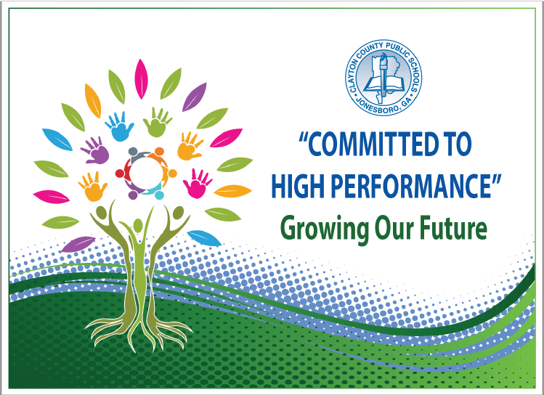
Strategic Goals
- To increase academic achievement for all students in Clayton County Public Schools as evidenced by state, national, and international assessment results
- To provide and maintain a safe and orderly learning environment
- To create an environment that promotes active engagement, communication, accountability, and collaboration of all stakeholders to maximize student achievement
- To provide high quality support services delivered on time and within budget to promote high performance in the Clayton County Public Schools
- To recruit, develop, and retain highly qualified and effective staff
Action Plan

Performance Objective 1: By 2023, Clayton County Public Schools will increase the percentage of student scoring at the Proficient and/or Distinguished levels on the Georgia Milestones to at least 80% in each content area.
GADOE School Improvement Systems: Coherent Instruction, Effective Leadership, Family and Community Engagement, Professional Capacity
Action Steps/ Tasks | Timeline | Project Leader(s) and School Level Person(s) Monitoring | Resources/ Funding | Check Points/ Related Artifacts and Evidence | Professional Learning  Activity and Date  (where applicable)
Increase the percentages of 3rd grade students reading at or above a 670 Lexile, 4th grade students reading at or above a 840 Lexile and 5th grade students reading at or above a 920 Lexile by 10% as measured by the Georgia Milestones Assessment | August 2018 – May 2019 | Principal  Assistant Principal  Title I Academic Coach | myON reading program - Title I General Funds | myON usage/Lexile reports  Lexile goal sheets for tracking  Lexile goal posted in each classroom  Lexile leveled books  GADOE website | “Using Lexiles to Increase Reading Skills” PD
Implement targeted well-planned instruction and assessments to ensure mastery of basic skills and to build conceptual understanding of skills that all students demonstrate orally, visually and in writing | August 2018 – May 2019 | Principal  Assistant Principal  Title I Academic Coach | None | CCPS Framework for High Performance  Collaborative planning minutes  Lesson plans  TKES observations  Walk-throughs  Assessments and data  District benchmarks | “Rigor and Relevance” PD
Utilize a data analysis protocol that allows teachers to systematically disaggregate and analyze assessment data biweekly | August 2018 – May 2019 | Principal  Assistant Principal  Title I Academic Coach | None | Data analysis sheets  Data charts  iReady Reading and Math intervention screeners (BOY, MOY, EOY) | “Data Analysis” PD

Supplemental Supports: What supplemental action steps will be implemented for these subgroups?
Economically Disadvantaged | Foster and Homeless
Small group instruction will be provided. Various collaborative teaching models will be utilized by the classroom and support teachers to provide well-planned, standards-based, cohesive instruction that meets the needs of all students. | Small group instruction will be provided. Various collaborative teaching models will be utilized by the classroom and support teachers to provide well-planned, standards-based, cohesive instruction that meets the needs of all students.
English Learners | Migrant
The ESOL teacher will co-teach, provide small group instruction, and/or differentiate instruction. | Small group instruction will be provided. Various collaborative teaching models will be utilized by the classroom and support teachers to provide well-planned, standards-based, cohesive instruction that meets the needs of all students.
Race/Ethnicity/Minority | Students with Disabilities
Small group instruction will be provided. Various collaborative teaching models will be utilized by the classroom and support teachers to provide well-planned, standards-based, cohesive instruction that meets the needs of all students. | The DES teachers will co-teach, provide small group instruction, and/or differentiate instruction.

Performance Objective 2: Over the next five years, Clayton County Public Schools will increase the graduation rate from 69.6% to 90% or higher.
GADOE School Improvement Systems: Coherent Instruction, Effective Leadership, Family and Community Engagement, Professional Capacity
Action Steps/ Tasks | Timeline | Project Leader(s) and School Level Person(s) Monitoring | Resources/ Funding | Check Points/ Related Artifacts and Evidence | Professional Learning  Activity and Date  (where applicable)
Monitor the fidelity of the implementation of the Early Intervention Program (EIP). | August 2018 - May 2019 | Principal  Assistant Principal | iReady  DIBELS (K-1)  Title I Funding | Ensure that all teachers receive adequate training and are able to schedule effectively  Review collaborative lesson plans to ensure alignment with the GSE  Evaluate data regularly to ensure that progress monitoring is occurring in a timely manner and to evaluate the program’s implementation | iReady Math training

Supplemental Supports: What supplemental action steps will be implemented for these subgroups?
Economically Disadvantaged | Foster and Homeless
Teachers will use data to inform instruction and provide various strategies to differentiate the learning for individual students. | Teachers will use data to inform instruction and provide various strategies to differentiate the learning for individual students.
English Learners | Migrant
The ESOL teacher will provide visuals, graphic organizers, sentence frames, manipulatives, and/or utilize cooperative learning. | Teachers will use data to inform instruction and provide various strategies to differentiate the learning for individual students.
Race/Ethnicity/Minority | Students with Disabilities
Teachers will use data to inform instruction and provide various strategies to differentiate the learning for individual students. | The DES teachers will provide visuals, graphic organizers, sentence frames, manipulatives, and/or utilize cooperative learning.

Performance Objective 3: By 2023, Clayton County Public Schools will increase the number of students absent less than 10% of their enrolled academic year.
GADOE School Improvement Systems: Effective Leadership, Supportive Learning Environment, Family and Community Engagement, Professional Capacity
Action Steps/ Tasks | Timeline | Project Leader(s) and School Level Person(s) Monitoring | Resources/ Funding | Check Points/ Related Artifacts and Evidence | Professional Learning  Activity and Date  (where applicable)
Provide incentives for students (NBA – Never Been Absent celebration, perfect attendance awards, sock hop dance) | August 2018 – May 2019 | Assistant Principal  Counselor  Attendance Committee | School  Funds | Monthly/semester attendance reports | None
Increase tracking of student attendance by classroom teachers each week and school-wide each month | August 2018 – May 2019 | Assistant Principal  Counselor  Attendance Committee |  | Attendance committee meeting minutes  Follow up monthly | None

Supplemental Supports: What supplemental action steps will be implemented for these subgroups?
Economically Disadvantaged | Foster and Homeless
Teachers will track individual student attendance frequently and provide incentives. | Teachers will track individual student attendance frequently and provide incentives.
English Learners | Migrant
The ESOL teacher will track individual student attendance frequently and provide incentives. | Teachers will track individual student attendance frequently and provide incentives.
Race/Ethnicity/Minority | Students with Disabilities
Teachers will track individual student attendance frequently and provide incentives. | The DES teachers will track individual student attendance frequently and provide incentives.

Performance Objective 4: By 2023, Clayton County Public Schools will decrease the number of discipline infractions while increasing employee morale and community support.
GADOE School Improvement Systems: Effective Leadership, Supportive Learning Environment, Family and Community Engagement, Professional Capacity
Action Steps/ Tasks | Timeline | Project Leader(s) and School Level Person(s) Monitoring | Resources/ Funding | Check Points/ Related Artifacts and Evidence | Professional Learning  Activity and Date  (where applicable)
Follow the behavior management system in all classrooms consistently (behavior charts) | August 2018 – May 2019 | Assistant Principal  Behavior Committee | Professional Learning Classes | Classroom observations  Monitor discipline referrals for student and teacher frequency | “Classroom Management” PD provided by the District
Utilize Positive Behavior Intervention System (Stepping Stones to Success) | August 2018 – May 2019 | Assistant Principal  Behavior Committee  Counselor | None | School-wide book study on The Seven Habits of Happy Kids by Sean Covey  Provide staff mentors for students in need  Offer small group sessions to present alternative strategies | None

Supplemental Supports: What supplemental action steps will be implemented for these subgroups?
Economically Disadvantaged | Foster and Homeless
Teachers will communicate more frequently with students to identify concerns and offer solutions. Teachers will use a variety of strategies to encourage good behavior. | Teachers will communicate more frequently with students to identify concerns and offer solutions. Teachers will use a variety of strategies to encourage good behavior.
English Learners | Migrant
The ESOL teacher will provide incentives. | Teachers will communicate more frequently with students to identify concerns and offer solutions. Teachers will use a variety of strategies to encourage good behavior.
Race/Ethnicity/Minority | Students with Disabilities
Teachers will communicate more frequently with students to identify concerns and offer solutions. Teachers will use a variety of strategies to encourage good behavior. | The DES teachers will communicate more frequently with individual students to identify concerns and offer solutions. Teachers will use a variety of strategies to encourage good behavior.

